Textile Engineering Design Project (TE-408)
Guidelines for Report Writing
- Document type:
The report should be type written as a MS Word document.
- Report Size:

- Page Size: The size of Pages in report should be A4
- Report Length: Between 10000 and 12000 words excluding all appendices.

- Number of Copies:
Two (02) hard copies of project report and one electronic copy are to be submitted.
Both copies should be a printout (color printout if required). The electronic copy should be submitted on a CD/DVD.
CD/DVD: having 3 File Folders:
Folder-1: Softcopy of Project Report,
PowerPoint Presentation of Final Exam and Software (if applicable)
Folder-2: Data used for the Project.
Folder-3: All Tables/Catalogues etc.
- Layout of Script:
Type script should be one and half spaced and on one side of Paper only.
Caption, footnotes, quotations and references may be Single spaced.
Times New Roman with 12 font size is to be used.
Only footnotes can use a 10 size font with single spacing.
- Margins (Text):
Left hand side: 1.5” Right hand side: 1”
Top: 1” Bottom: 1”

- Box File:
Minutes of Meetings and all relevant reference materials which do not from part of the report such as Tables/Catalogue, internet down loads, software, etc. must be submitted in box file.
On top of the box file information mentioned in ‘Sample Front Cover’ should be printed.
- Binding:
All project reports must be hard bound in Navy Blue color. No other form of bind shall be acceptable.
Any large size diagram must be properly folded and placed in a pocket of the bounded report to be provided at the end for this purpose. The Front Cover Title (same as ‘Sample Front Cover) should be printed in Golden Letters.

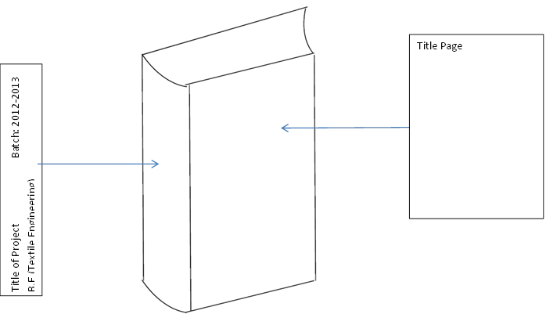
Structure of Final Year Design Project Report
A thesis is made up of several sections, arranged in the sequence shown in below;
SECTION | REQUIREMENT | REMARKS
Title (sample Front Cover) | Required | Unnumbered but considered as (i)
Certificate (sample certificate) | Required | Lowercase Roman numeral (ii)
Dedication | Optional | Lowercase Roman numeral
Acknowledgements | Required | Lowercase Roman numeral
Abstract | Required | Lowercase Roman numeral
Table of Contents | Required | Lowercase Roman numeral
List of Tables | Required | Lowercase Roman numeral
List of Figures | Required | Lowercase Roman numeral
List of Symbols and Abbreviations | Required | Lowercase Roman numeral
Main Body | Required | Arabic numeral starting with the page number (1,2,3,…)
References | Required | Arabic numeral continued with text
Appendices | Optional | Arabic numeral continued with text

- Acknowledgements
Acknowledgements must be written on a single page only. Its purpose is to record the author’s appreciation for individuals or organisations that provided their assistance either directly or indirectly in the preparation of the thesis.
- Abstract
The abstract is a short summary of the thesis. It should describe the rationale and objectives (problem statement), the methodology, as well as the findings and conclusion of the study undertaken. The abstract must not be longer than 250 words.
It must be written with a spacing of one and a half (1½) lines.
- Table of contents
The table of contents must begin on a new page. The information is organised by chapter, topic and page number. Every chapter, topic and page number shown in the table of contents must correspond to the same chapter, topic and page number in the thesis. Sub-titles may be displayed up to three levels only.
- List of tables
This page contains a list of all tables presented in the thesis. Information such as table numbers, table captions and the corresponding page numbers where the tables appear must be shown clearly in the list. The list must be ordered by chapter.
- List of figures
All illustrations included in the text such as maps, charts, drawings, graphs, pictures and photos are considered as ‘Figures’. The list of figures contains all the figure numbers, titles and the corresponding page numbers on which they appear. The list of figures must be ordered by chapter.
- List of symbols and abbreviations
This page lists down all the symbols and abbreviations used in the text in alphabetical order.
- Main body of Report
Text in the thesis must be organised in titled chapters. The titles must reflect the content of the chapter. Every chapter must begin on a new page.
There is no restriction on the total number of chapters in a thesis. Generally, a thesis will have the following basic structure.
- Introduction
This chapter describes the aim, objectives and scope of the research as well as the structure of the thesis.
- Literature review
The literature review is a critically written and comprehensive account of the published works on a topic by accredited scholars and researchers. It is directly related to the thesis, providing information on theories, models, materials and techniques used in the research.
- Methodology or Experimentation
This important chapter explains in detail the samples, instruments, materials, procedures and data gathering methods used in the research.
- Results and discussion
This chapter explains the results and research findings through written text, figures, tables, and/or other means.

- Conclusions and Future Work
Conclusions are drawn based on the research findings and their implications. Future works are also discussed.
- References in the text
When an information or idea is taken from a source, the author of the source must be acknowledged in the text. References cited in the text must be written according to the style prescribed in IEEE 2006.
Example:
Fluid Mechanics is the study of forces and flow within fluids [1].
- Tables in the text
All tables must be numbered using Arabic numerals. Table numbers must be linked to the chapter number. For example, the third table appearing in Chapter 4 is numbered, “Table 4.3”.
The caption for a table is placed 1.5 lines above the table and written in Times New Roman font, size 12 without a period at the end and left justified with single line spacing between lines. The text in the table must be written using Times New Roman font, size 10 and single line spacing between lines.
If a table extends beyond the end of a page, its continuation on the next page must, for example, be labeled, “Table 4.3 (continued)”
- Figures in the text
All figures must be of high quality and numbered using Arabic numerals. Figure numbers must be linked to the chapter number. For example, the third graph/chart/image/etc appearing Chapter 4 is numbered, “Figure 4.3”.
The caption for a figure is placed 1.5 lines below the graph/chart/image/etc and written in font size 12 without a period at the end with single line spacing between lines.
- Mathematical equations
Mathematical equations must be numbered using Arabic numerals. Equation numbers must be written at the end of the equation and linked to the chapter number. For example, the numbers (4.3) and (4.4) are given to the third and fourth equations respectively that appear in Chapter 4, as follows:
y ² = 3x ² + 3xy + C | (4.3)

z = 10x ⁶ + 9y ⁵+8 ⁴ + 7y ⁶ x ⁵ + 6y ⁵ x ⁴ + 5x ⁴ | (4.4)

- References
References are the sources referred to when preparing a report and cited in the text of the report. It is required to list down all cited materials in references using IEEE 2006 (MS Word).
References be provided in following form:
Author’s Second Name, Initials, Title, Year of Publishing, Volume, Page Range, Year.
Example:
[1] White, F.M, Fluid Mechanics, Second Edition, McGraw-Hill, New York, 1986.
[2] Brebbia, C.A. & Aliabdi, M.H., (eds.), Industrial Applications of the Boundary Element Method, Computational Merchanics Publcations: Southamption and Boston, 1993.
- Appendices (optional)
The appendix section gives an author the opportunity to include materials that can provide additional information in the text to support the study. These materials include tables, charts, computer programmes etc.
- Headings/Sub-heading:
Heading and Sub-headings, article numbers etc. should all be left aligned.
- The main heading of the chapters should be 14 point font, bold, all upper case and Centered (not underlined).
Example: CHAPTER 4
(14 pt bold) 1 $½$
EXPERIMENTATION
(14 pt bold)
- First level subheading should be 12 point font, upper case and left justified, with one complete line space above and below the heading. The numbering format to be made is #.#
Example 4.1 TWELVE POINT UPPER CASE LEFT JUSTIFIED
- Second level subheading should be 12 point font, mixed case and left justified with one complete line space above and below the heading. The numbering format to be used is #.#.#
Example 4.1.1 Twelve Point Mixed Case left justified
- Third level heading should be 12 point font, mixed case and left justified with one line space above and below the heading. The number format to be used is #.#.#.#
Example 4.1.1.1 Twelve Point Mixed Case left justified
- Fourth level heading’ should be 12 point font, mixed case and left justified.
Text to start in the same line as of heading, separated by a colon and two character spaces. Numbering format to be used is #.#.#.#. #
Example 4.1.1.1.1 Twelve Point Mixed Case left justified: Text to start from here
Example:
CHAPTER 1
TITLE OF THE CHAPTER
1.1 Title of the subtopic – level 1
1.1.1 Title of the sub-subtopic– level 2
1.1.1.1 Title of the sub-sub-subtopic – level 3
1.1.1.1.1Title of sub-sub-sub-subtopic: level 4
- Header
Department of Textile Engineering (11 pt.)
Example:
Department of Textile Engineering

- Footer

Page number (11 pt.)

Example:

1

